[MALLA REDDY TECHNICAL CAMPUS]
[Department of CSE[AI&ML]
A FINAL PROJECT REPORT ON
POWER GRID CONNECTION PLANNER
Minimum-Cost Distribution Network Design and Shortest Backup Routing using Prim, Kruskal and Dijkstra Algorithms
Submitted by
[J.SOWMIKA] – Roll No. [25MVCSMR0572]

[N.SUSHMA] – Roll No. [25MVCSMR0594]

[P.VYSHNAVI] – Roll No. [25MVCSMR0600]
[V.SHRUTHI] – Roll No. [25MVCSMRO625]
Under the guidance of
[SUBRAHMANYAM ], [PROFESSOR]
Department of [CSE(AI&ML], [MALLA REDDY TECHNICAL CAMPUS],
[MALLA REDDY VISHWAVIDHYAPEETH UNIVERSITY]
Academic Year: [2026– 2027]

1. Abstract and Introduction

1.1 Project Overview
The Power Grid Connection Planner is a web-based prototype that designs a minimum-cost power distribution network for a set of substations and calculates the cheapest backup route when a connection fails. It models the grid as a weighted undirected graph, where substations are vertices and candidate transmission lines are edges weighted by construction cost.

1.2 Problem Background
Power utilities must connect many substations while keeping cable, land and construction cost low. Every extra line adds cost, but too few lines leave the network fragile. When a line fails, operators need an alternative path quickly. Choosing these links by hand does not guarantee the lowest cost and is difficult to explain or audit.

1.3 Proposed Solution
The system applies Prim's and Kruskal's algorithms to build a minimum spanning tree (MST) and uses Dijkstra's algorithm to find least-cost paths. Users can step through each algorithm, view a decision log explaining why each line was accepted or rejected, mark any line as failed, and immediately see the rebuilt network and the best backup route.

1.4 Purpose of the Project
The purpose is to turn classical Design and Analysis of Algorithms (DAA) concepts into a working, understandable tool, so that the result is not just a number but a visible, explainable set of decisions.

2. Problem Statement, Objectives and Scope

2.1 Problem Statement
To design a minimum-cost power distribution network connecting all substations, and to calculate the shortest (least-cost) backup routes when a connection fails.

2.2 Objectives
- Construct a minimum-cost network that connects every substation without cycles.
- Demonstrate and compare Prim's and Kruskal's algorithms on the same input.
- Compute least-cost routes between any two substations using Dijkstra's algorithm.
- Simulate connection failures and show the resulting rebuilt network and detour cost.
- Present every decision visibly so users understand why a result was chosen.

2.3 Scope
The system covers graph input, MST construction, failure simulation, shortest-path routing, step-by-step visualisation and a comparison summary. Costs are assumed to be non-negative and static. Electrical engineering factors such as load capacity, voltage drop and real-time faults are outside the current scope.

2.4 Target Users
- Power distribution planners and utility engineers (for planning and what-if analysis).
- Students and teachers of algorithms (for learning how the algorithms behave).
- Infrastructure analysts comparing network layouts.

3. Features and Functional Requirements

3.1 Main Features
- Interactive graph of substations and candidate lines with costs.
- Step-by-step Prim and Kruskal execution with a plain-language decision log.
- Click-to-fail / restore for any transmission line.
- Dijkstra backup route with total cost, per-node distance table and detour compared with the original.
- Comparison table showing total cost, links built and work done by each algorithm.

3.2 User Functionalities
- Select the algorithm (Prim or Kruskal) and, for Prim, the starting substation.
- Step forward, step back, play, pause and reset the algorithm.
- Choose source and destination substations for routing.
- Fail or restore a line and review the effect.

3.3 CRUD Operations
The current prototype keeps the grid in memory. Its update operation is toggling a line between working and failed. In the Flask backend design, the full set of operations is defined as follows.
Operation | Substation | Transmission line
Create | Add a new substation with name and position | Add a line between two substations with a cost
Read | List substations and view details | List lines, costs and status
Update | Rename or move a substation | Change cost or mark failed / working
Delete | Remove a substation and its lines | Remove a line

3.4 Authentication and Validation
The prototype is a single-user tool and does not require login. In a deployed version, planners would sign in with role-based access (viewer and editor). Input validation rules apply in both versions:
- Line costs must be non-negative numbers (required for Dijkstra's correctness).
- A line must connect two existing, different substations.
- Duplicate lines between the same pair are rejected or merged.
- If failures disconnect the grid, the system reports unreachable substations instead of a false result.

3.5 System Requirements
Item | Requirement
Processor / RAM | Any modern dual-core CPU, 4 GB RAM
Operating system | Windows, Linux or macOS
Browser | Current Chrome, Edge, Firefox or Safari
Software (backend version) | Python 3.10+, Flask, Node.js for the React front end

4. Algorithms and Methodology

4.1 System Workflow
The workflow is Input → Processing → Algorithm → Output. The user supplies substations, candidate lines and costs. The system builds a weighted graph and removes any failed lines. The selected algorithms run on the resulting graph, and the output is the network, its total cost, the backup route and the decision log.
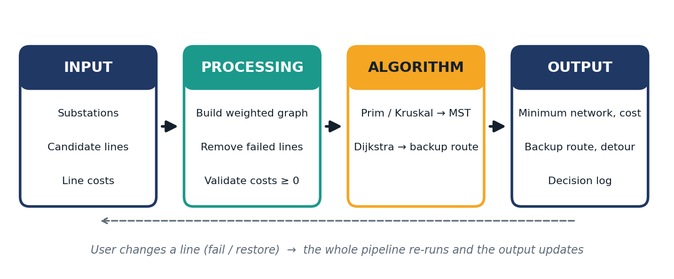
Figure 1: System workflow – Input → Processing → Algorithm → Output

4.2 Algorithms Used
Prim's algorithm grows the MST from a start vertex by repeatedly adding the cheapest edge that joins the current tree to a new vertex. Kruskal's algorithm sorts all edges by cost and adds each edge that does not create a cycle, using a Disjoint Set (Union-Find) structure to detect cycles. Dijkstra's algorithm maintains tentative costs, repeatedly selects the unexplored vertex with the lowest cost, relaxes its edges, and reconstructs the final path from predecessor links.
Algorithm | Purpose | Complexity (V vertices, E edges)
Prim | Build MST from a start node | O(E log V) with a priority queue; O(V²) with arrays
Kruskal | Build MST by sorted edges | O(E log E) for sorting plus near-constant Union-Find operations
Dijkstra | Least-cost path, non-negative costs | O((V + E) log V) with a priority queue; O(V²) with arrays

Prim suits dense grids, Kruskal suits sparse ones, and running both on the same input verifies that the minimum cost is the same. Dijkstra is chosen for routing because all costs are non-negative.

4.3 Development Methodology
An iterative approach was followed: (1) model the grid as a graph; (2) implement each algorithm and record its steps; (3) build the visual interface; (4) add failure simulation and backup routing; (5) test against hand-calculated results.

4.4 Data Flow
User actions (select algorithm, fail a line, choose route endpoints) update the application state. The state is passed to the algorithm functions, which return an ordered list of steps and final results. The interface renders those steps as graph colours, log entries and tables.
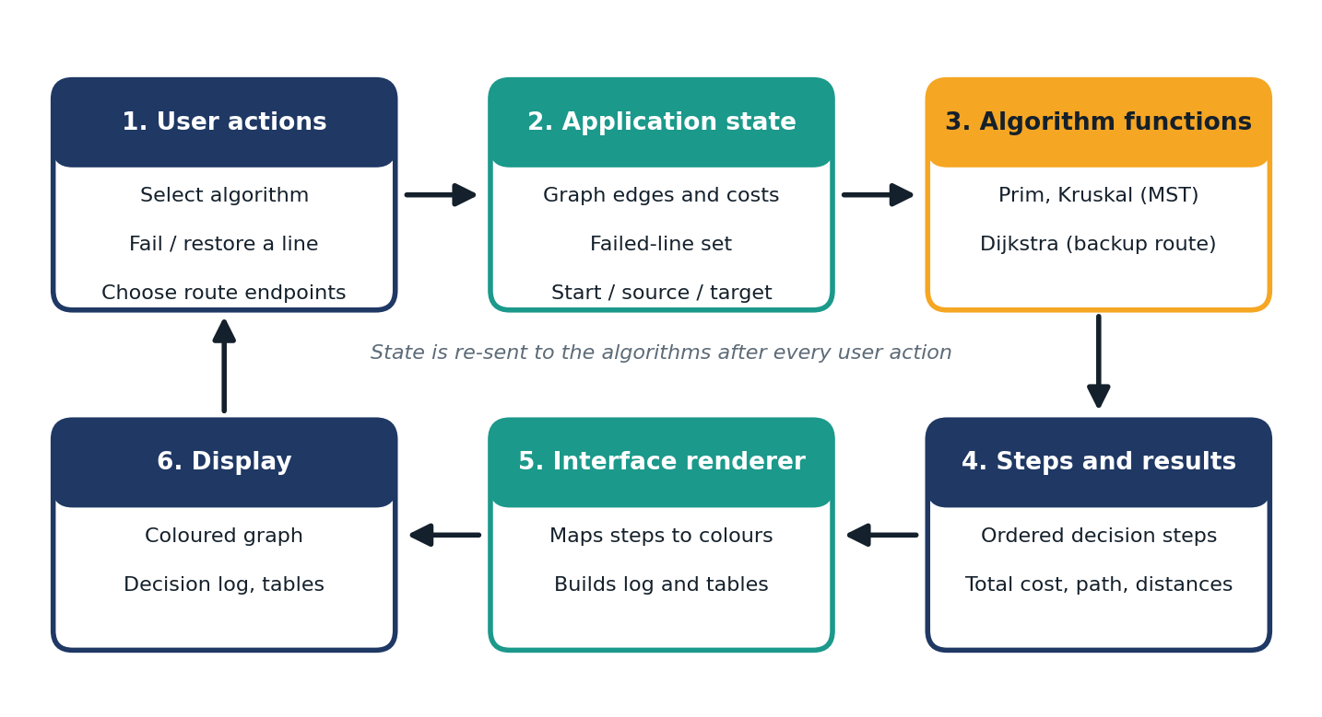
Figure 2: Data flow diagram

5. Technologies and Implementation
Layer | Technology
Frontend | HTML, CSS, JavaScript with SVG graph rendering (prototype); React for the extended version
Backend | Python with Flask REST API (planned endpoints: /mst, /shortest-path)
Database | Prototype: in-memory arrays. Extended version: SQLite or PostgreSQL with tables for substations and lines
Tools | VS Code, Git, browser developer tools
APIs | Internal REST API; optional mapping API for real coordinates in future

5.1 Implementation Details
- Graph representation: an edge list of (u, v, cost) with vertex coordinates for drawing.
- Prim: repeatedly scans for the cheapest edge with exactly one endpoint in the tree and records each addition.
- Kruskal: sorts the edges, then uses Union-Find with path compression and records each accepted or rejected edge.
- Dijkstra: array-based, keeping distance and predecessor lists, then rebuilds the path backwards from the destination.
- Failure simulation: failed edges are excluded from the edge list before every algorithm run, so all results update together.

6. Results, Testing and Performance

6.1 Project Results
On the sample grid of 9 substations and 17 candidate lines, both Prim and Kruskal produce a network of 8 links with a total cost of 29. When the Hub–East line fails, the least-cost route from the Plant to East rises from 15 to 16, a detour of 1.

6.2 Testing Methods
Functional testing compared the system output with results calculated by hand, and edge-case testing covered disconnected grids. The expected values below were worked out manually and then checked against the prototype, which was run in a headless Chromium browser with the stated steps. All seven cases matched.

6.3 Test Cases
ID | Test case | Expected result | Result
T1 | Prim from Plant on sample grid | 8 links, total cost 29 | Pass
T2 | Kruskal on sample grid | 8 links, total cost 29 | Pass
T3 | Prim from East (different start) | Total cost 29 | Pass
T4 | Dijkstra Plant → East, no failures | Least cost 15 | Pass
T5 | Fail Hub–East, Dijkstra Plant → East | Least cost 16 (detour +1) | Pass
T6 | Fail all three Plant lines | Plant reported unreachable; Kruskal builds 7 links (cost 25); Prim started at the isolated Plant builds 0 links; Dijkstra shows 'No route' | Pass
T7 | Restore a failed line | Original results return (cost 29, route cost 15) | Pass

Test T6 shows that Prim only spans the component that contains its starting substation, so for a split grid the user should start Prim from a connected substation or rely on Kruskal, which builds a forest of the connected parts.

6.4 Performance Analysis
In theory, heap-based Prim and Kruskal scale as O(E log V) and O(E log E), and heap-based Dijkstra as O((V + E) log V). The prototype uses the simple array versions: Prim rescans the edge list each time it adds a vertex, and Dijkstra scans the edge list for each visited vertex, so both grow roughly as O(V·E). Running times were measured on random connected graphs with E = 4V and costs from 1 to 100, using the median of five runs in Chromium (headless, sandbox machine).
Substations (V) | Lines (E) | Prim (ms) | Kruskal (ms) | Dijkstra (ms)
100 | 400 | 3.4 | 0.2 | 1.2
500 | 2,000 | 38.5 | 0.8 | 6.7
1,000 | 4,000 | 157.9 | 1.4 | 28.0
2,000 | 8,000 | 704.5 | 4.1 | 121.8

Kruskal is the fastest here because sorting plus Union-Find is cheap on sparse graphs. Prim's time grows steeply as the grid grows, which confirms that a priority-queue version would be the right improvement for networks of thousands of substations. The sample grid itself runs in well under a millisecond.

6.5 Screenshots / Output
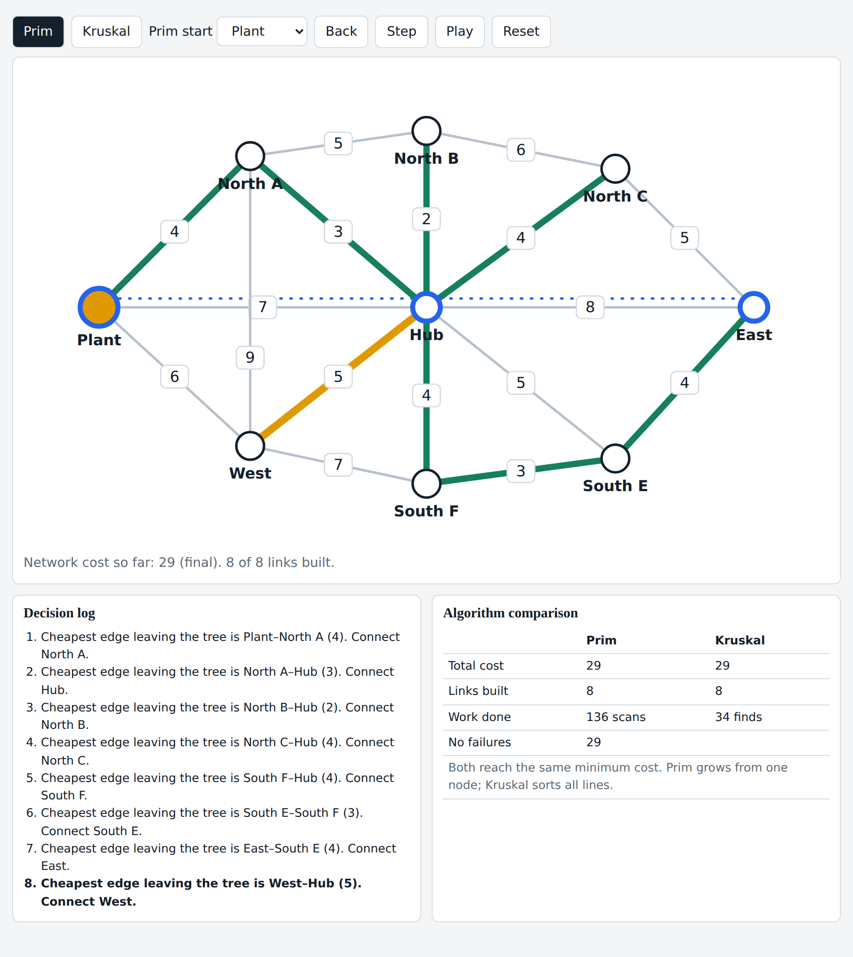
Figure 3: Prim's algorithm after completion, with the decision log and comparison table
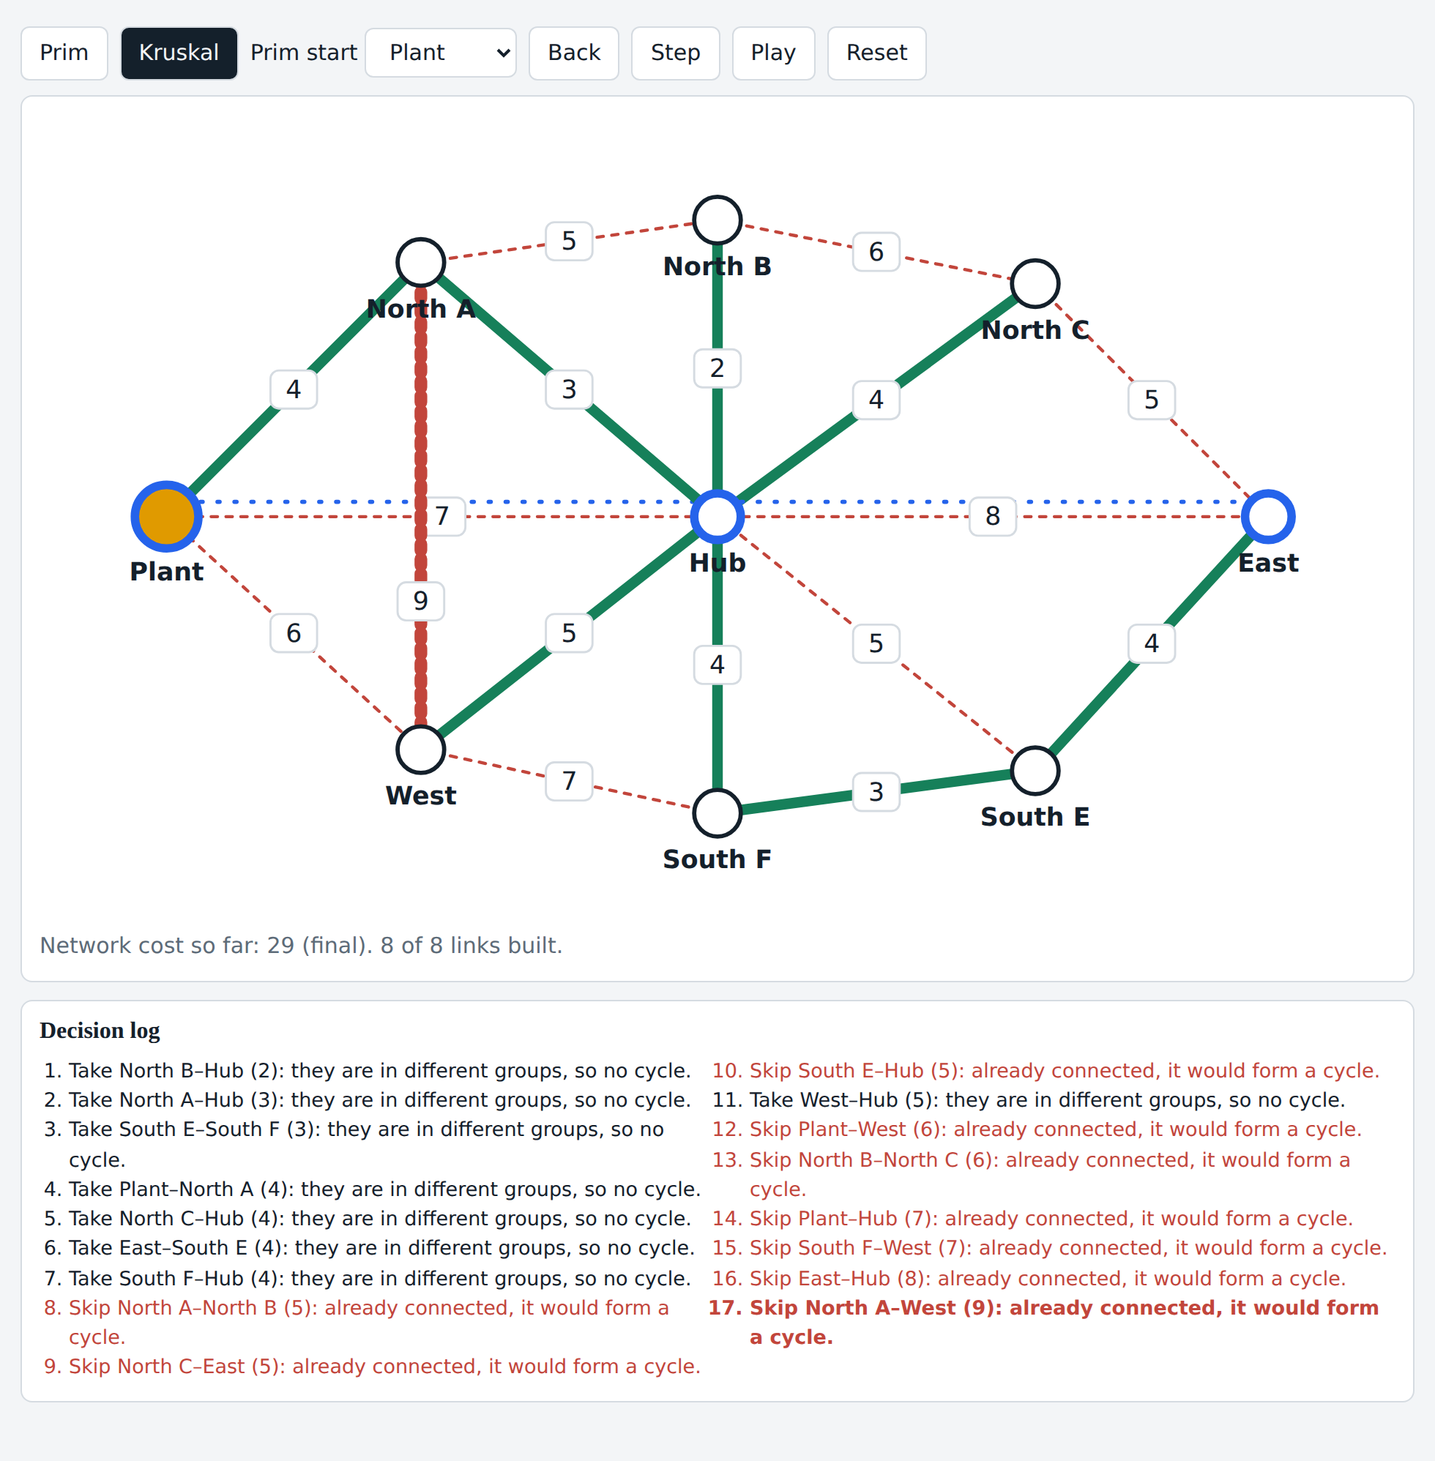
Figure 4: Kruskal's algorithm – accepted lines (green) and rejected lines that would form a cycle (red dashed)
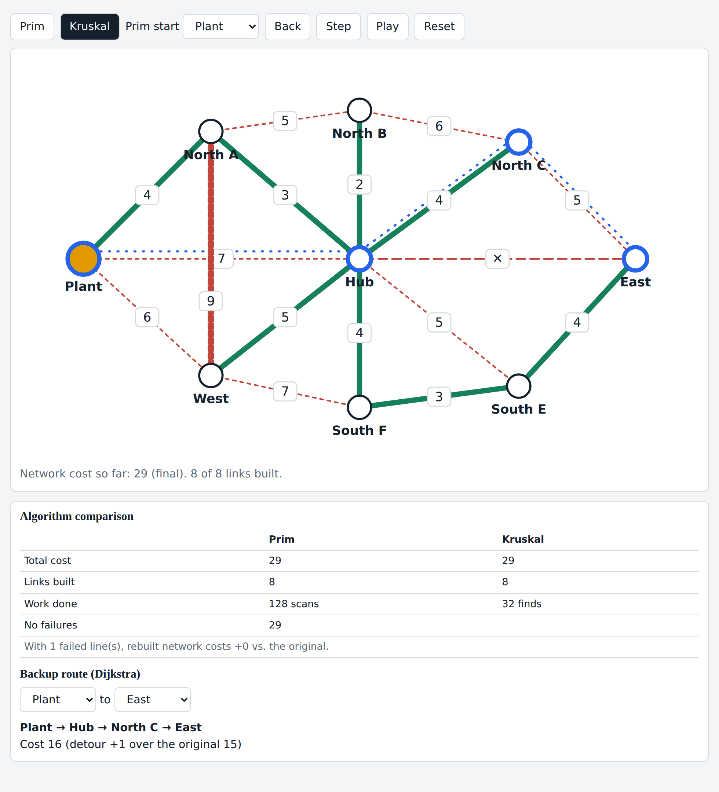
Figure 5: Hub–East line failed (dashed red); Dijkstra backup route Plant → Hub → North C → East costs 16

7. Conclusion, Future Scope and References

7.1 Conclusion
The project shows how greedy algorithms and shortest-path search combine to plan and protect a power network. Prim and Kruskal agree on the minimum cost, and Dijkstra supplies a clear backup route after a failure. Making each decision visible makes the result understandable, not just correct.

7.2 Future Enhancements
- Load real map and substation data and compute costs from distance.
- Add line capacity and load limits to the model.
- Detect faults automatically from live sensor data.
- Complete the Flask and React stack with persistent storage and user roles.
- Use heap-based implementations and benchmarks for large networks.

7.3 References
- T. H. Cormen, C. E. Leiserson, R. L. Rivest and C. Stein, Introduction to Algorithms, MIT Press.
- R. C. Prim, 'Shortest connection networks and some generalizations', Bell System Technical Journal, 1957.
- J. B. Kruskal, 'On the shortest spanning subtree of a graph and the traveling salesman problem', Proceedings of the AMS, 1956.
- E. W. Dijkstra, 'A note on two problems in connexion with graphs', Numerische Mathematik, 1959.
- Flask documentation, https://flask.palletsprojects.com
- React documentation, https://react.dev

